Resizing videos with ffmpeg
(Source: https://superuser.com/questions/547296/resizing-videos-with-ffmpeg-avconv-to-fit-into-static-sized-player/1136305#1136305)

A simple method is to use the force_original_aspect_ratio option in the scale filter.
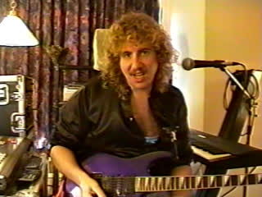
Original image. Represents a 640x480, 4:3 aspect ratio video.

In these examples the original image will be scaled to fit into a 1280x720, 16:9 aspect ratio output while preserving the original aspect ratio. To do this you can either:
- Add black bars (or any other color) with pad filter to pillarbox or letterbox the image to fit properly, or
- Use the crop filter to cut off the excess

Pillarbox or letterbox to fit
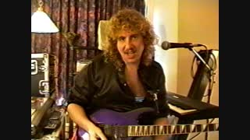
Pillarboxed image. Fitting a 640x480 (4:3) input into a 1280x720 (16:9) output.

ffmpeg -i input -vf "scale=1280:720:force_original_aspect_ratio=decrease,pad=1280:720:-1:-1:color=black" output

- This will upscale the image. If you want to avoid upscaling see the example below.
- Letterboxing will occur instead of pillarboxing if the input aspect ratio is wider than the output aspect ratio. For example, an input with a 2.35:1 aspect ratio fit into a 16:9 output will result in letterboxing.

Same as above but without upscaling
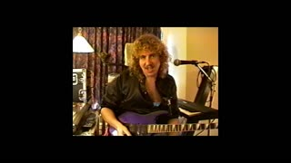
640x480 (4:3) input into 1280x720 (16:9) output without upscaling.

ffmpeg -i input -vf "scale='min(1280,iw)':min'(720,ih)':force_original_aspect_ratio=decrease,pad=1280:720:-1:-1:color=black" output

Crop to fit
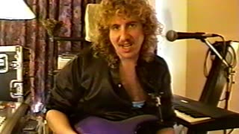
Cropped image. 4:3 input aspect ratio, 16:9 output aspect ratio.

Using the crop filter to cut off the excess:
ffmpeg -i input -vf "scale=1280:720:force_original_aspect_ratio=increase,crop=1280:720" output

Using input images that each vary in size
If you are inputting a series of images, and the images vary in size, add the eval=frame option in the scale filter, such as:
ffmpeg -i input -vf "scale=1280:720:force_original_aspect_ratio=decrease:eval=frame,pad=1280:720:-1:-1:color=black" output

